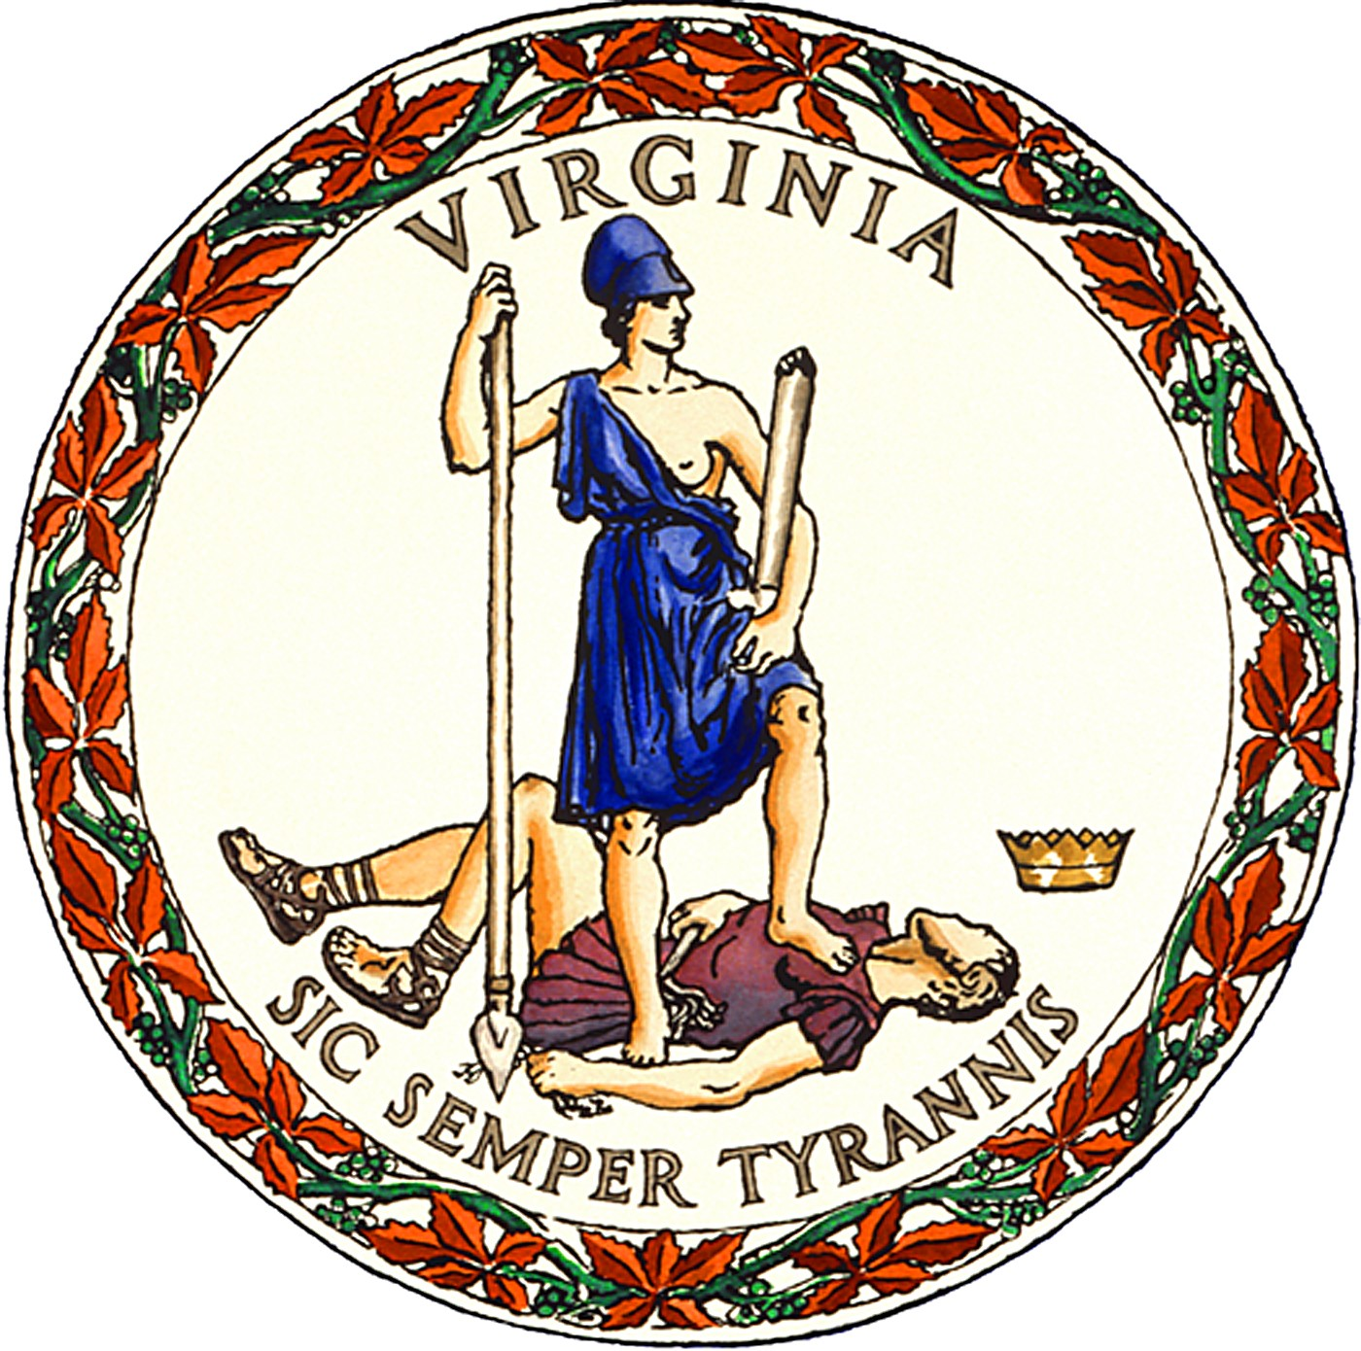

PUBLIC NOTICE
for the
November 5, 2024, Election
in
Bland County, Virginia

In-person, early voting for Bland County voters will be available at the location, date, and hours listed below beginning Friday, September 20, and ending Saturday, November 2.

- 20 Fairground Street, Bland, VA 24315

Hours: Monday-Friday, 8:00 a.m.-4:00 p.m., and
Saturdays, October 26 and November 2, from 9:00 a.m.-5:00 p.m.

Ballot dropboxes will be available the same dates, times, and location listed above.

In addition, dropboxes will be available at the location listed above

- Monday, November 4, from 8:00 a.m.-4:00 p.m., and
- Tuesday, November 5 (Election Day), from 6:00 a.m.-7:00 p.m.

Dropboxes will also be available at all regular polling places on Election Day, Tuesday, November 5, from 6:00 a.m.-7:00 p.m.

STACY TIBBS GRADY
Director of Elections and General Registrar

Va. Code §§ 24.2-701.2(E), -707.1(C)

