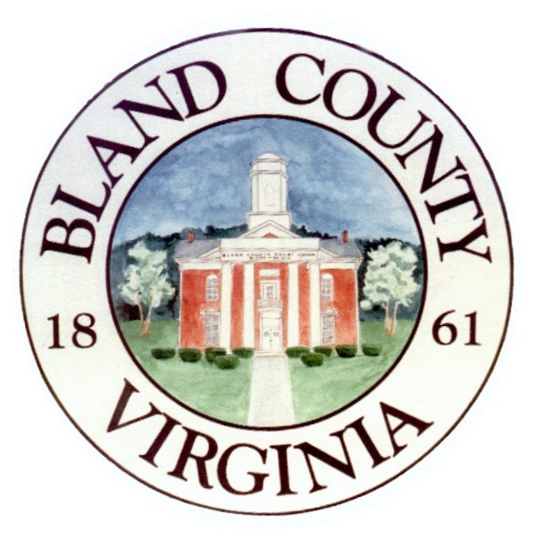

The Bland County Voter Registration and
Elections Office will open at 12:00pm,
Monday, August 26, 2024.
If you need immediate assistance, please call (540) 818-5191.
Sorry for
any inconvenience. Thank you.
Stacy Tibbs Grady
