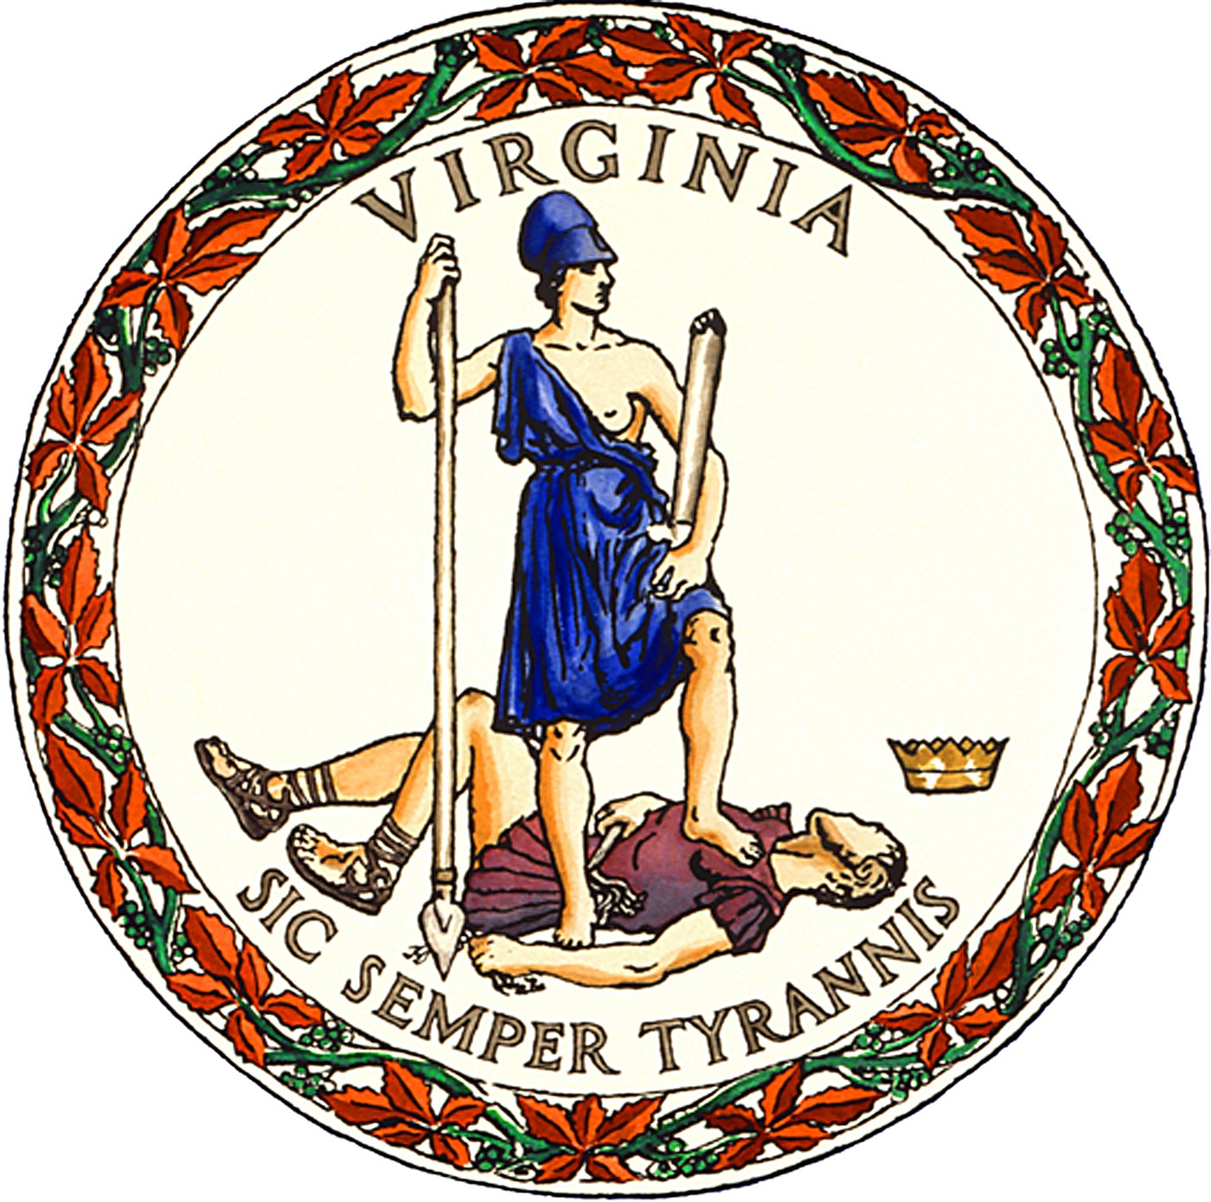

PUBLIC NOTICE
for the
March 5, 2024 Dual Party Primary
in
Bland County, Virginia

In-person, early voting for Bland County voters will be available at the location, date, and hours listed below beginning Friday, January 19th, and ending Saturday, March 2nd.

- 20 Fairground Street, Bland, VA 24315, Monday-Friday, 8:00 AM-4:00 PM. This office will also be open on Saturday, February 24th, and Saturday, March 2nd, from 9:00 AM-5:00 PM.

Ballot drop-boxes: a ballot drop-box will be available for voted ballots the same dates, times, and locations listed above for in-person, early voting as well as on Monday, March 4th, from 8:00 AM-4:00 PM. Drop-boxes will also be available at all regular polling places on Election Day, March 5th, from 6:00 AM until 7:00 PM.

STACY TIBBS GRADY
Director of Elections and General Registrar
Posted: January 8, 2024

Va. Code §§ 24.2-701.2(E), -707.1(C)

